Nursery News and Banter May 2019

Our new starts are settling in very well with our older children being a great help towards this, being helpful and welcoming.
This Photo by Unknown Author is licensed under CC BY-SA-NC
We enjoyed an outdoor learning day planned by the school. We built dens, made mud pies in the sensory garden and had our hotdog and beans snack by the campfire.
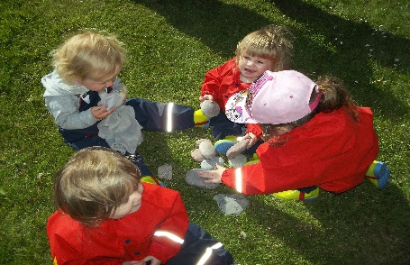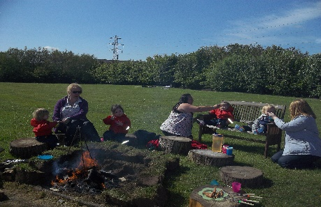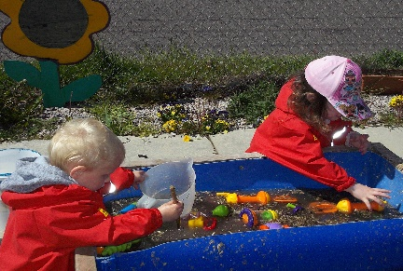
We also had some special visitors to Nursery! Some lambs came to see us, we got to feed them and pet them.
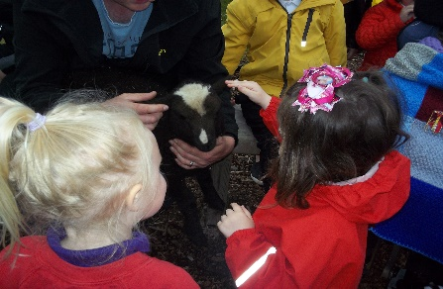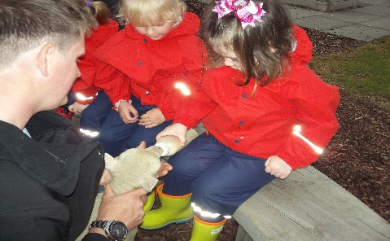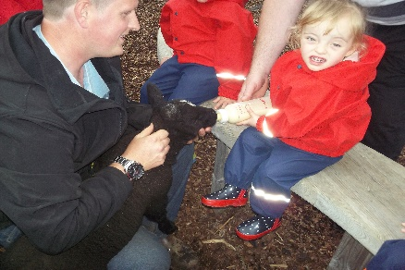

You will have noticed your child’s learning journey has been moved. This is to allow your child to access them and for you to look through it together. These belong to you and your child, please comment and add to this as you wish.

Nursery keep a stock of food stuffs and household products and are happy to supply anytime. If you have a shortage and would benefit from some of these products, please see a member of staff who would be happy to help and talk to you.
This Photo by Unknown Author is licensed under CC BY
Cash for kids Superhero day – A huge thank you to all parents and children who dressed up, had fun and contributed to a great cause. We raised a fantastic £85 for local children.
This Photo by Unknown Author is licensed under CC BY-NC-ND
The childsmile team will be visiting Nursery on Tuesday 18th June at 12:00 to apply fluoride varnish. All children of age that attend that day will be done. Parents and children who do not attend that day will be invited in at this time.

Dates for your diary

Thursday 10th May – M & M production of The Jungle Book.
Monday 3rd June – Nursery closed, mid-term holiday.
Tuesday 18th June – Childsmile, Fluoride varnish 12:00.
Thursday 4th July – Nursery stop for 2 weeks summer break
--------------------------------------------------------------------------------------------------------------------------

May 2019
Please comment on parts of the newsletter i.e. outdoor day, fluoride varnish.
Thank you.

