Nursery News and Banter March 2020

A warm welcome to our new Nursery child, Sapphire. We hope you settle in, any questions or suggestions please don’t hesitate to ask a member of staff.

As part of Nursery working together with families, we are offering parents and extended family the chance to stay with their chid and enjoy a school meal over a lunch time. This a fantastic opportunity for you to experience your child’s Nursery and for them to show you what they can do. A donation to be made to the kitchen for your own meal. A note will be in your child’s Home/Nursery diary with a choice of dates when it is their turn. We look forward to seeing you all.

World Book Day – we a celebrated world book day on Thursday 5th March. Some senior pupils came into nursery and read your child a story. We joined the school in the hall for book themed activities. Thank you to everyone that brought your favourite book from home to share with Nursery.

The school and Nursery will be holding an open afternoon on Wednesday 25th March. This is a lovely opportunity for siblings and extended family to come see your child’s Nursery. You are all welcome to come along to play and have a cuppa.
The School parent council have organised a family games night on Friday 27th March at 6:30. This is free, and refreshments will be provided. You are all welcome to come along and join in a variety of fun family games.

Our Nursery children’s clothes swap has and continues to be a huge success. We would like to thank those who have donated items towards this. Following on we are looking into an adult clothes swap. Donations of any decent clothing, jackets etc would be appreciated. What are your feelings on this? Would home items be useful also?

We are delighted to let you know we have secured the Fraserburgh Ambulance Service to come and provide our Wednesday group with some free first aid training!! A date is to be confirmed. We also have Lisa Lyall from Assembly of God to give advice and guidance towards budgeting on Wednesday 11th March.
Two Nursery Policies are attached for you to have a read over, ‘Stay, Play and Learn Wednesday Policy’ and ‘Inclusive Family Policy’. Any questions or comments please see a member of staff.

We would like to say a huge thank you to Steven and Nicholas, our Nursery dads and Gordon, Alison’s husband for helping with planting of apple and hawthorn trees. This would not have been possible without your contribution.
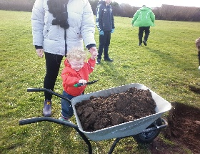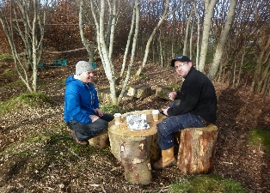
Easter Nursery – Dates and sessions will be discussed with parent/carers regarding Easter Nursery in due course. We will try to accommodate everyone as best we can. Some families do not want/need sessions during the holidays which is respected.

Staff training – Nursery staff are fortunate to be going on ‘Understanding and Working with Trauma and Adversity’ training on Wednesday 18th March. Elaine is also undertaking a 3 days first aid course and will be the Nursery and schools first aider.

Dates for your Diary
Wednesday 25th March – School/Nursery Open Afternoon
Friday 27th March at 6:30 – Parent council Family Games Night
Friday 3rd April – Last day of term, Easter Holidays

--------------------------------------------------------------------------------------------------------------------------
March 2020
Parents comments and suggestions.
Thank you.

