Garden Car Wash

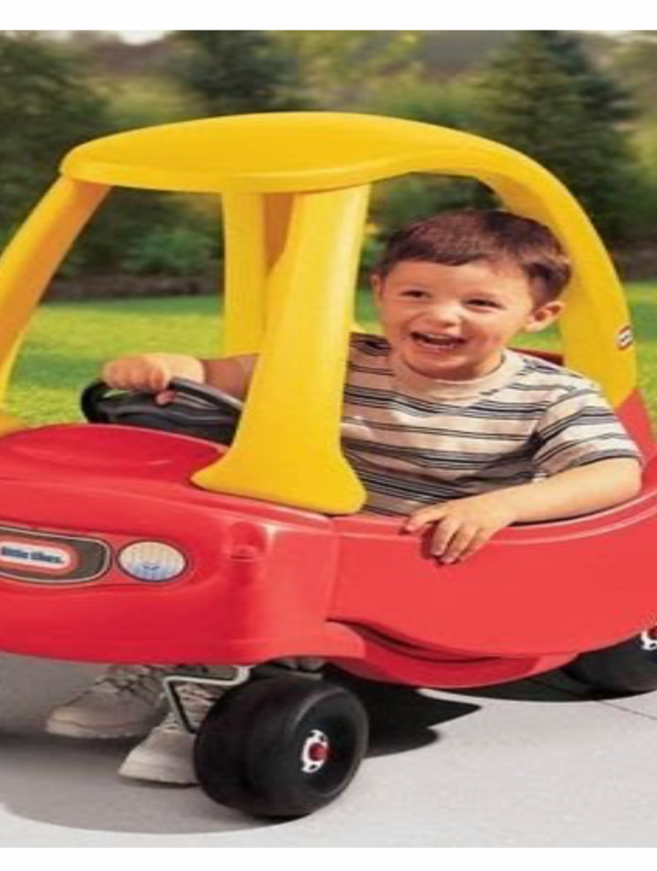

Lots of fun guaranteed!!
A Great way to get some fresh air and use up some energy.

All you need is a bucket of cosy water and some cloths and sponges.
The more bubbles the better!!

Line up any outdoor toys/bikes/cars that need a wash……..then get washing and splashing!

A hose could be introduced………..if you are feeling brave! Enjoy!

