Toilet roll art
Here is a craft made with an everyday material. Every household has toilet rolls and cardboard boxes or paper lying about. See how much fun you can have helping your child draw, glue and colour in. Please send in any photos of your creations.
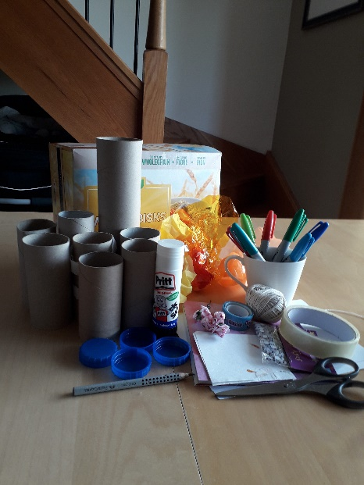 You will need -
Toilet or kitchen rolls, glue, Sellotape, paper, cardboard, pen or pencil, colouring pens, scissors.
If you have googly eyes (for crafts, not being personal) wool, stickers or any other crafting materials.
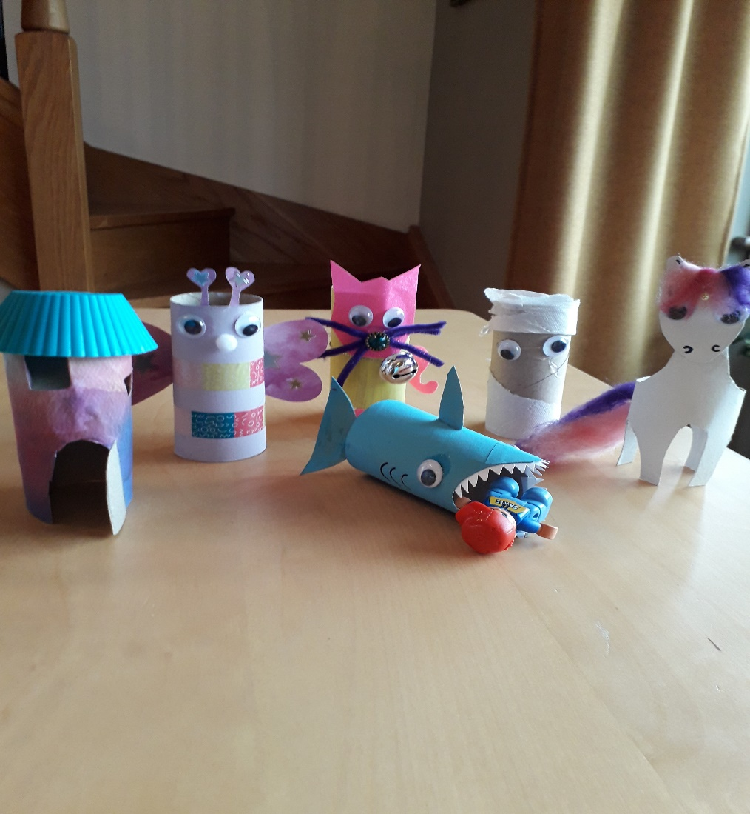
Shark – Cut out 2 triangles to make the mouth, use one for the tail. Make a hole on the top for the fin. Glue in paper teeth and eyes. Draw on gills.
Butterfly – Cut out 2 hearts for the wings and 2 smaller ones for the antenna. Glue on eyes, nose and decorate however you fancy.
Unicorn – Cut out 4 u shapes from the base to make legs. Halfway down from the top cut a shape for the neck. Make a head shape with the rest. Glue the head on. Add wool for the tail and mane. I screwed a little screw on the forehead for her horn.
Cat – Cut a face, paw and tail shape using paper or cardboard. Glue these on. I then added whiskers, a nose and bell.
Fairy house – I glued on paper then cut out a door and windows. The roof is a silicon cupcake case.
Mummy – I couldn’t get all the paper off the roll, so I glued on eyes to make a mummy or a first aid casualty.
Make any animal, vehicle, creature or building that you fancy.

