Westfield Community Hub Nursery
Fraserburgh

Vision, Values & Aims Policy
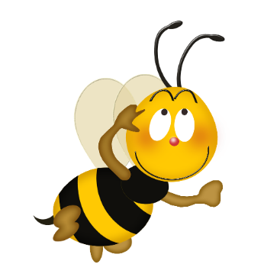

This policy was adopted at a meeting of:
Westfield Community Hub Nursery

On (date) …13th September 2022…………………………………..

Signed ……A Hollick……… . Designation ………Teacher….……………….

Through the ‘3Bs’ (Being, Belonging, Becoming) we aim to create a caring and nurturing setting that allows wellbeing, communication, curiosity, inquiry and creativity to flourish. We provide a safe, stimulating environment for all children where they can feel secure and valued. Through kindness and care we promote a sense of self as a valued individual. We enable the children to become confident individuals, effective contributors, successful learners and responsible citizens. We believe that when secure and happy each child will be ready to learn through play and will develop the necessary learning processes for life. We put a focus on the Wellbeing Indicators to form a basis of holistic development and care. We nurture a community based upon caring relationships, mutual respect, trust and confidence in which all children and adults are treated equally and fairly. We work with families and other agencies to give children the best possible start in life.

Monitoring of this Policy
It will be the responsibility of A Hollick to ensure all staff and families are familiar with the Vision, Values and Aims and are included in the devising of them.
This policy will be revised every 3 years.

Westfield Hub
Nursery

Our Mission Statement/Vision

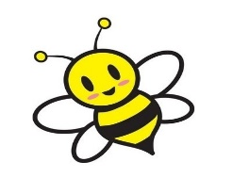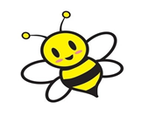

“We are an Early Years Hub that reaches
out to the heart of the community and
strives to enable every child and family to
achieve their full potential.”

September 2022

In our Nursery our Aims and Values are based on the 3B’s Belonging, Being and Becoming.

Belonging is central to Being and Becoming in that it shapes who children are and who they can become.

Belonging includes
Being part of a family – Families are children’s first and most influential educators.

Being part of a community – Knowing where and with whom you belong.

Belonging relies on positive relationships being formed in early childhood and throughout life.

Being in childhood is a time to be, to explore and make meaning of the world.

Being is to love, accept and celebrate who yourself and others are.

Being recognises the here and now, engaging with lifes joys and challenges whilst building and maintaining relationships with others.

Becoming; a child that knows where they belong and has the freedom to explore who they are can become a confident individual who can participate fully and actively in society.

Becoming involves children and families growing together embracing new experiences to make sense of the world around them.

Becoming reflects the process of rapid and significant change that occurs in early years as young children learn and grow.

